Part II

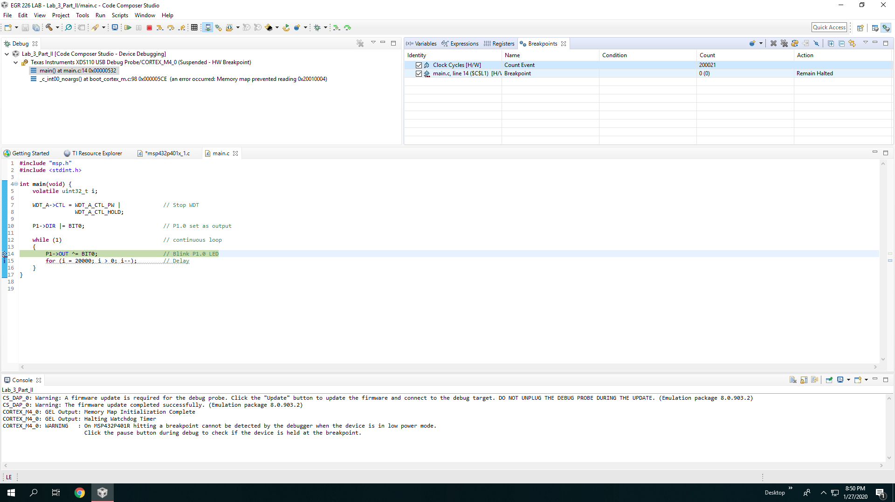

Figure #: 20000 cycles

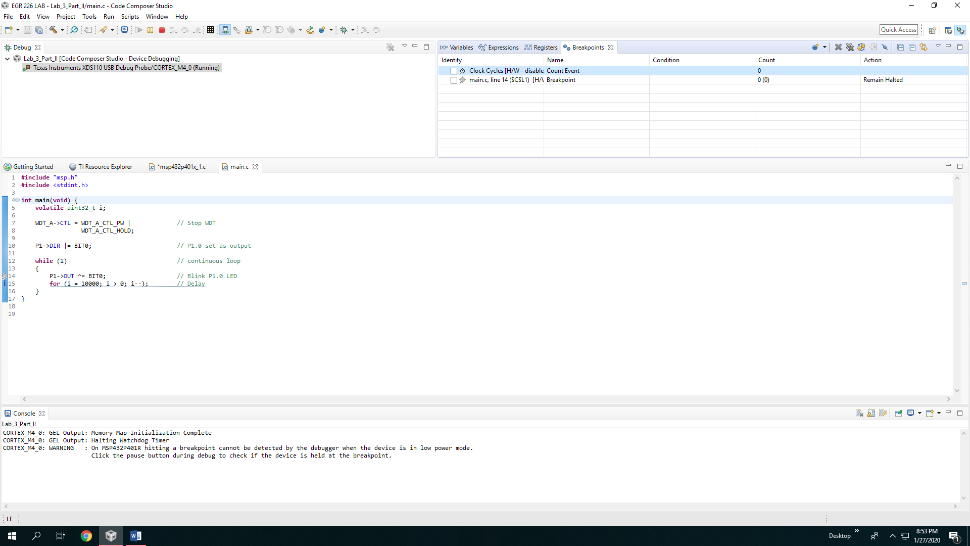

Figure #: 10000 cycles

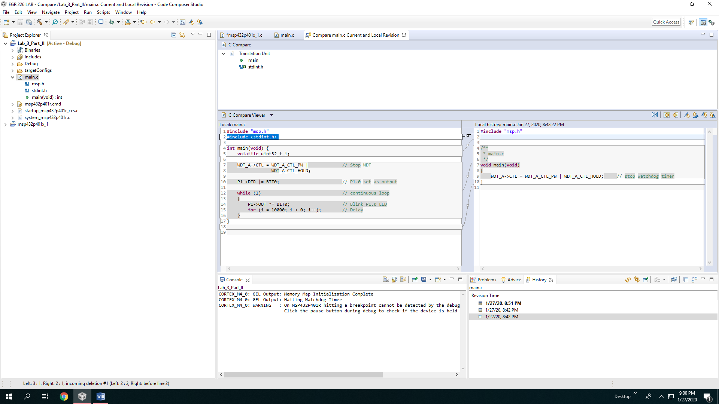

Figure #: comparison of new and revised

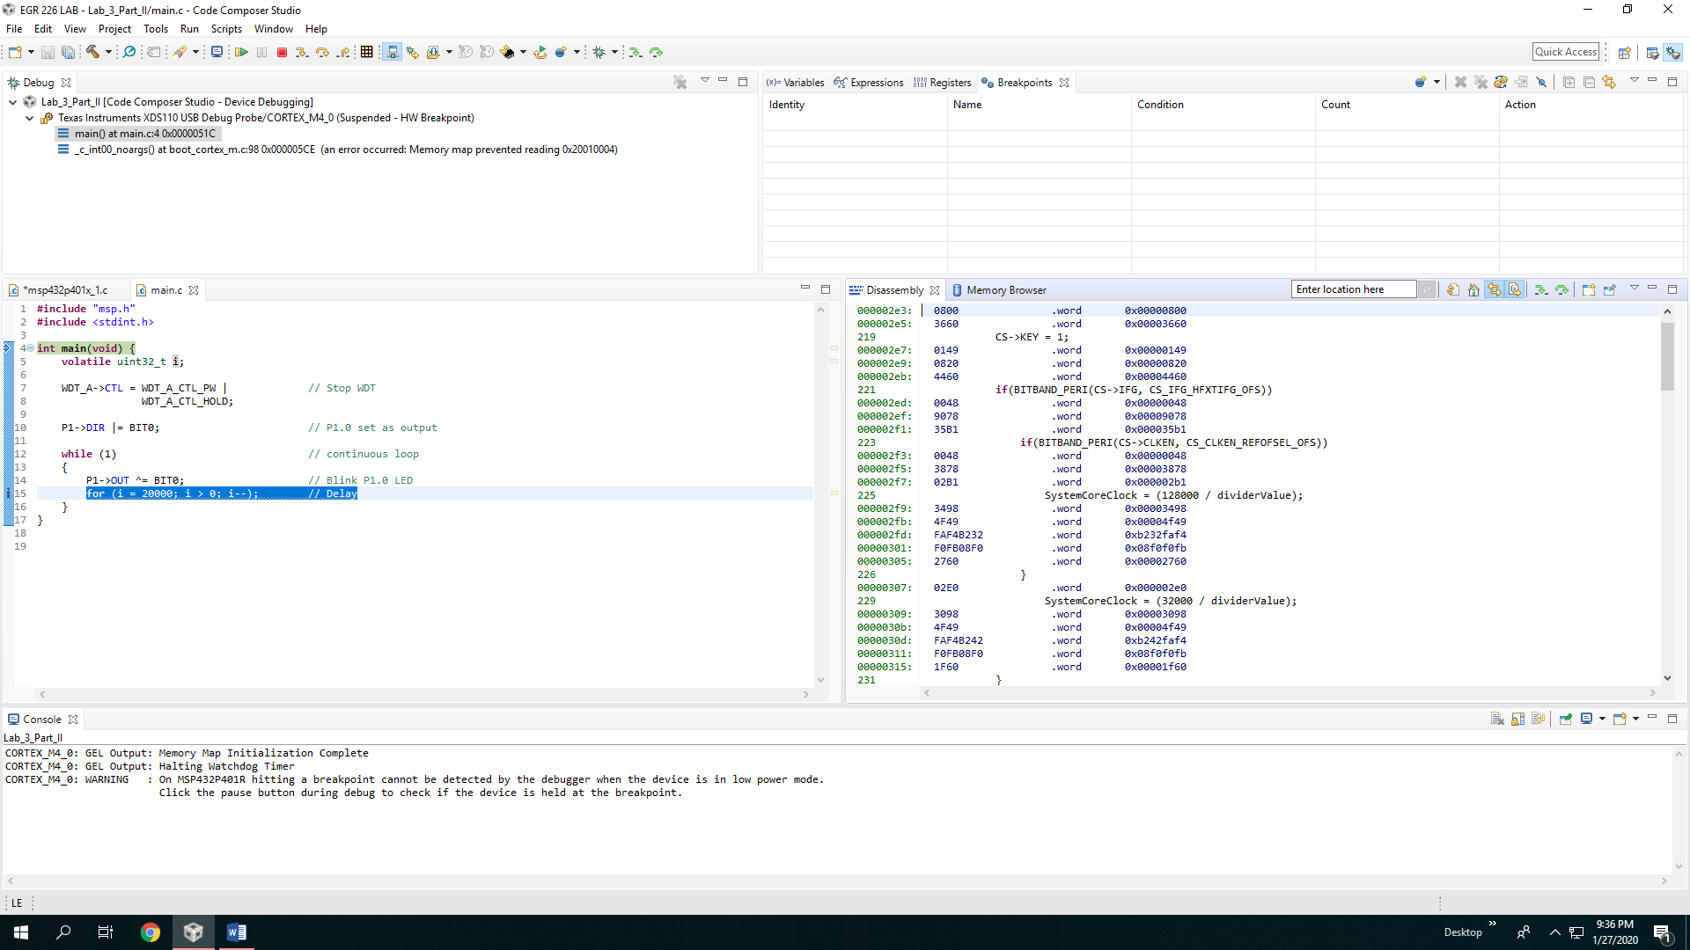

Figure #: Disassembly of the source code

PART III

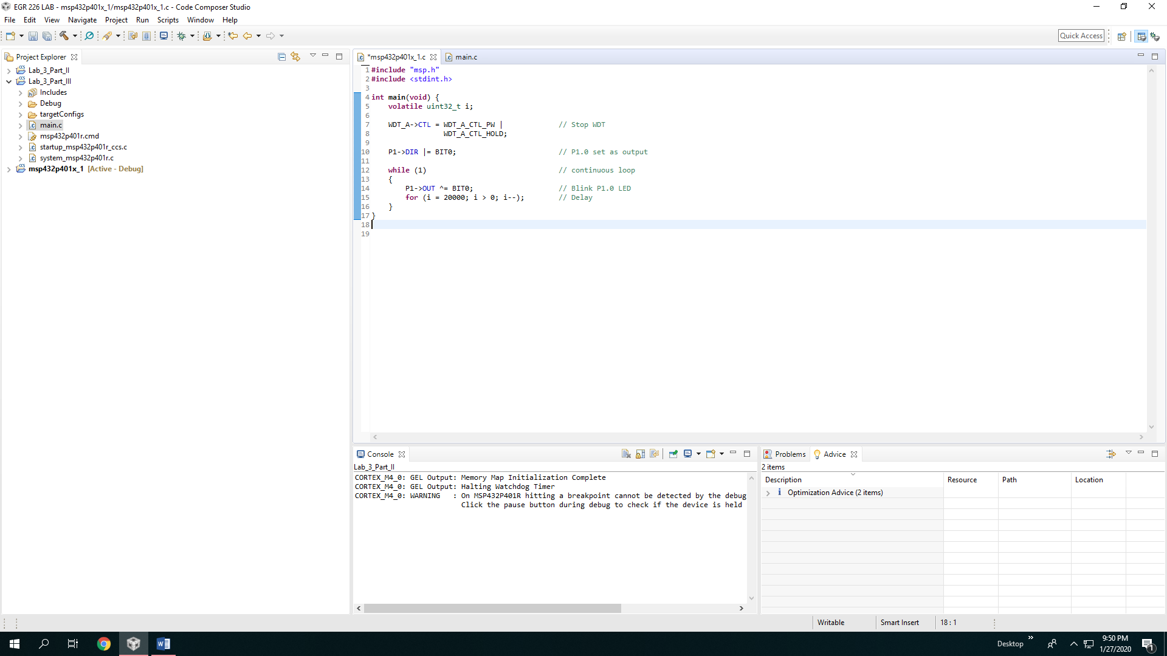

Figure #: Original imported source code from part II

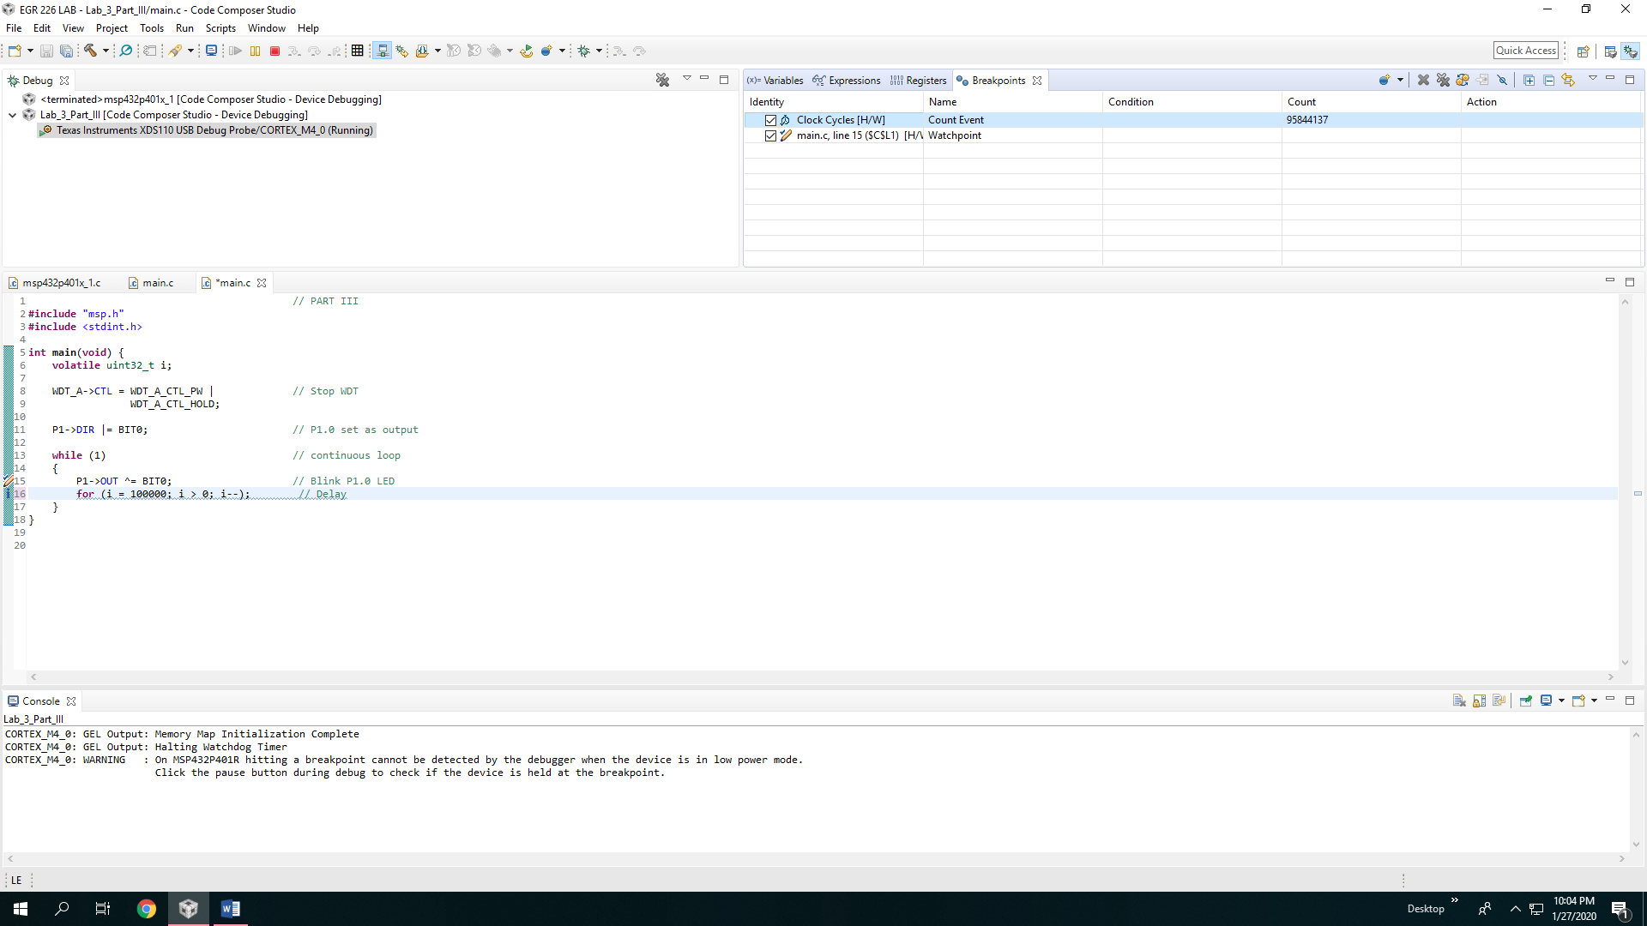

Figure #: Modified source code from part III, note the count is higher

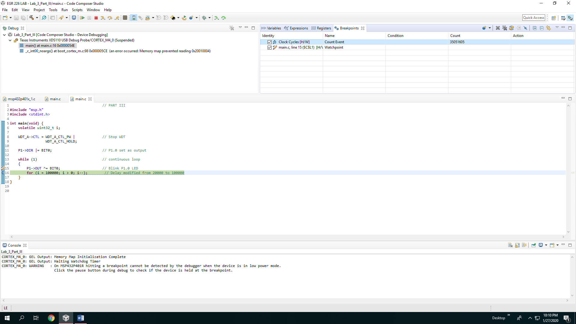

Figure #: Note the amount of count is higher

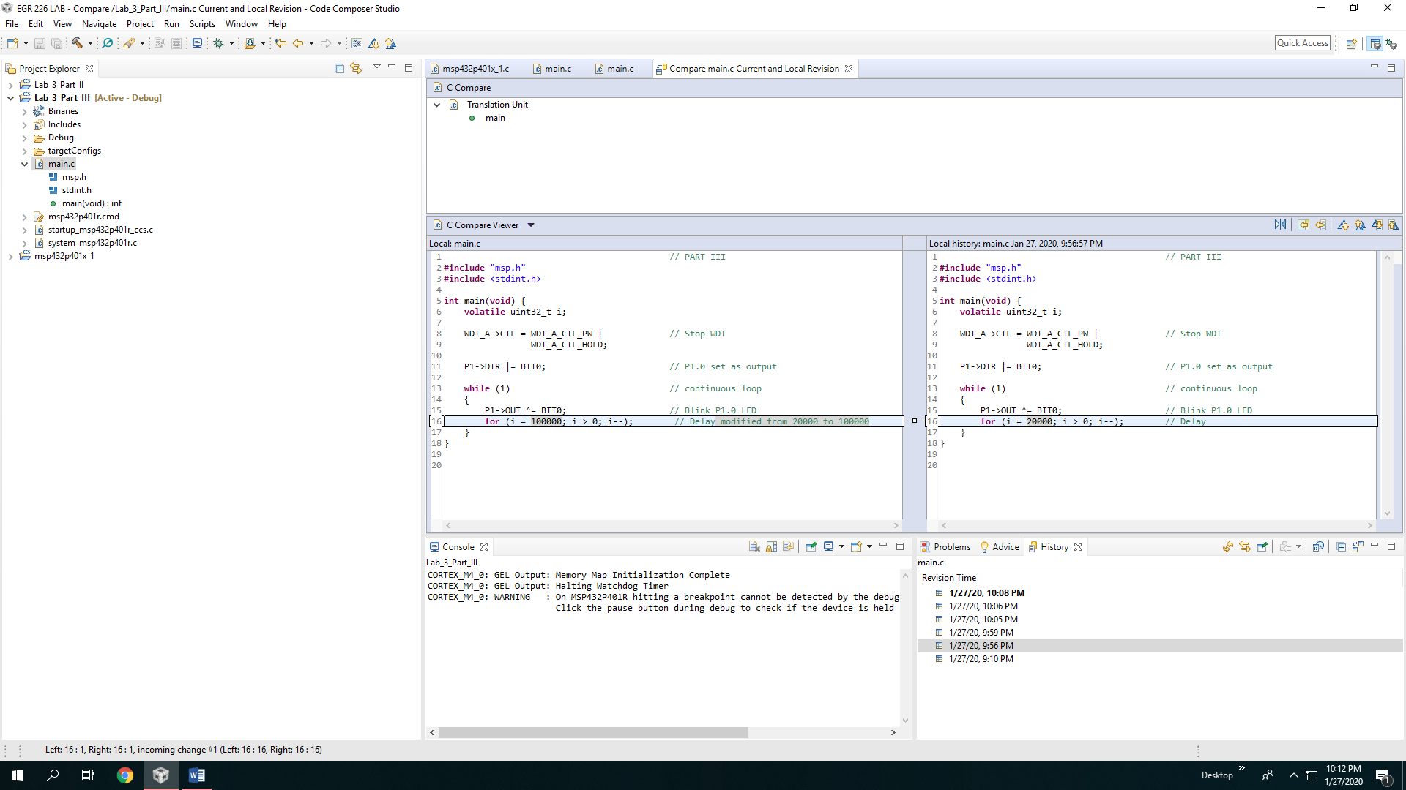

Figure #: Shows the imported vs the modified source code

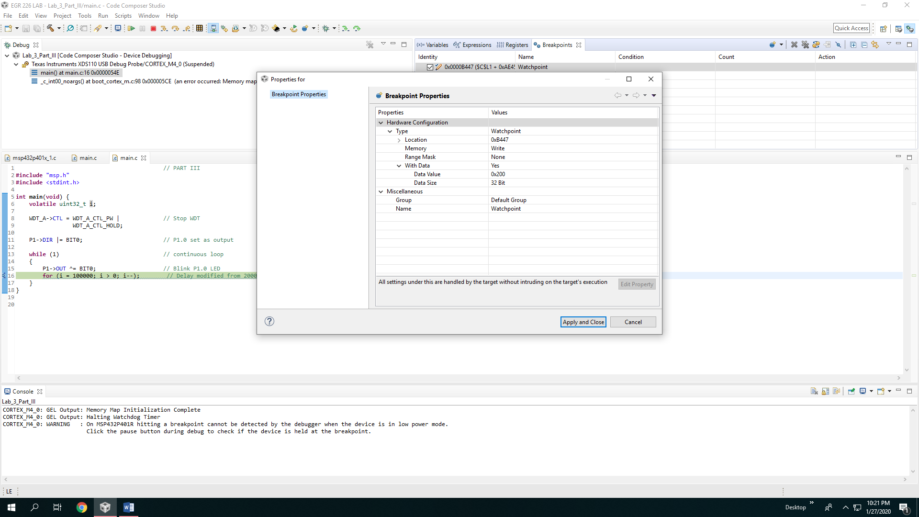

Figure #: shows a different data value for variable “I” at 0x200

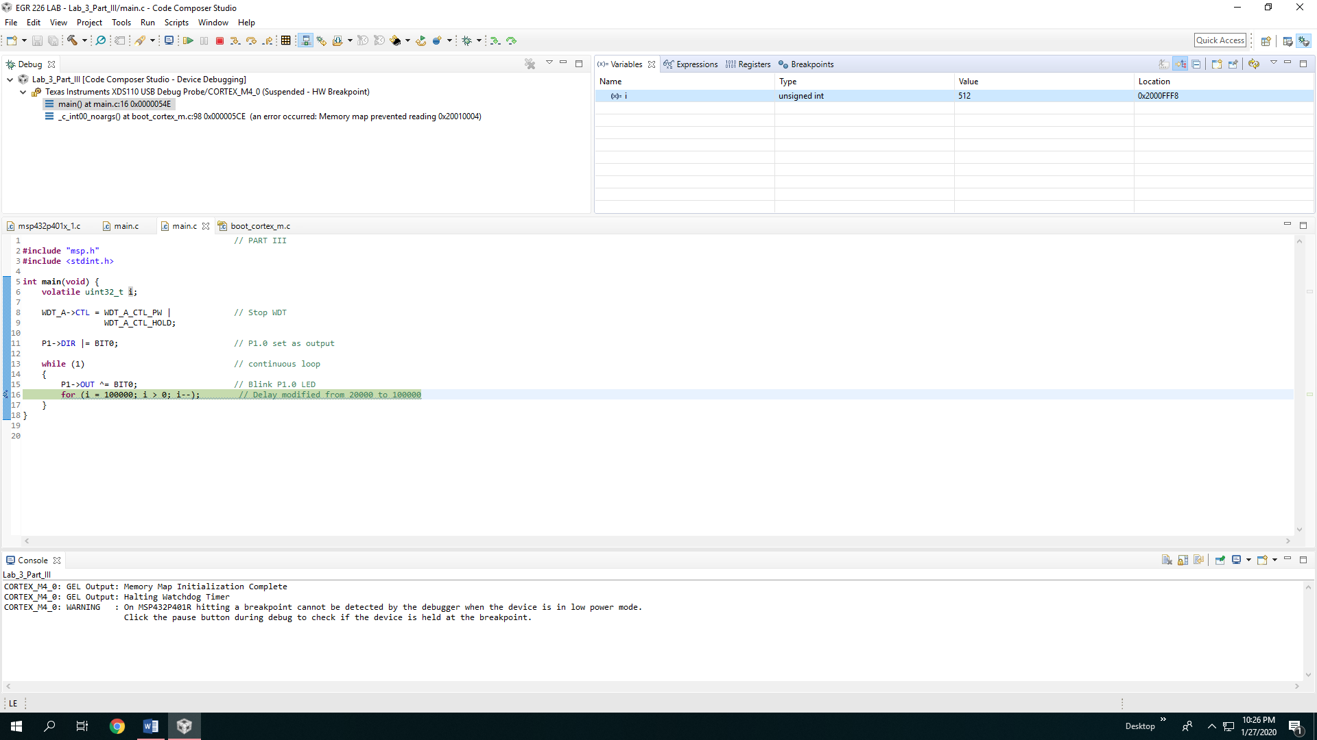

Figure #: Shows program suspended at 512 rather than 256

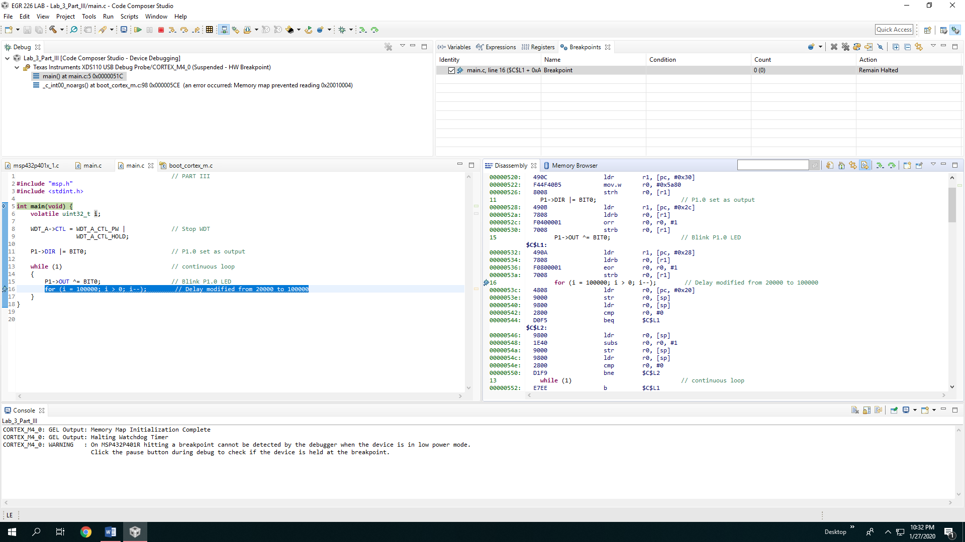

Figure #: Shows toggling and displays the disassembly